**Round 2**

### Experiment: Balancing of rotating masses in single plane

### 1) Story Outline:

The high speed of engines and other machines is a common phenomenon now-a-day. It is, therefore, very essential that all the rotating and reciprocating parts should be completely balanced as far as possible. If these parts are not properly balanced, the dynamic forces are set up. These forces not only increase the loads on bearings and stresses in the various members, but also produce unpleasant and even dangerous vibrations.[1]

The experiment involves two masses attached to a rotating shaft which is unbalanced and producing a large vibration because of centrifugal force produced by the rotating masses. The purpose of the experiment is to determine the phase angle, position and mass to balance the effect of the centrifugal forces.[1]

**2. Story:**

**2.1 Set the visual stage description:**

On the simulator page a user can observe a rotating shaft in front view and top view (Blue in colour) in the middle of the simulator screen. Two masses are attached to the shaft which is positioned perpendicular to the screen and rotating in anticlockwise direction. The two masses are represented with the two circles of blue colour named as 1 and 2 attached to the shaft with the help of two lines of light blue colour. The angle between each link can be seen after the simulation is paused with the help of coloured arc between the links and the value of which is displayed on the top of the screen. The red coloured link with the red colour mass (named as B) represents the balanced mass.

The user can see the variables on the right side of the screen, the values can vary with the help of slider given for each variable. The first and second variable is of mass, which is initially set on default for 300 kg and can be varied from 100 kg to 500 kg. The third and fourth variables are for the length of the attachment of masses to shaft, the user can vary the length of the attachment with the help of slider, initially the default length is set 20 cm for both the masses and can vary from 0 to 45 cm and the user can see the simultaneous changes in animation while changing the length. Similarly, the user can change the angle between the two masses by varying the fifth variable named as theta 1(deg). The default position of theta slider is 100.

On the bottom right corner of the simulator page user can perform control operations viz. pause/play, reverse, right, left. With the help of play/pause button user can pause or play the simulation. Reverse button for changing the direction of simulation. With the left and right button user can navigate to the next page of the simulation.

On the next page user can enter the analytically calculated values of mass, length and angel for balancing the two masses using particular sliders. The length and the angle theta can put through varying the slider and mass can be entered in the given space. The corresponding changes in the animation can be seen in simulation page. The user can check the correct answer, and % error in the result by clicking on submit button, results are shown in the bottom of the simulator screen in orange colour.

**2.2 Set User Objectives & Goals:**

* List the reasons for balancing of rotating mass
* Describe conditions to be satisfied to achieve balance in rotating bodies.
* Solve the mathematical equations acting on the rotating body
* Examine the analytical results with the simulation results
* Evaluate how change in mass and position can improve the balance of the rotating body.
* Attempt the assessment questions.

**2.3 Set the pathway activities:**

1. The m1 is set at 300 kg and can be varied from 100 to 500 kg.
2. The m2 is set at 300 kg and can be varied from 100 to 500 kg.
3. The r1 is set at 20 cm and can be varied from 0 to 45 cm.
4. The r2 is set at 20 cm and can be varied from 0 to 45 cm.
5. The theta 1 is set for 100 initially and can be varied from 0 to 360.
6. Click the next button in control menu to navigate to next page.
7. Put the value of the balancing mass length through slider with the help of analytical calculation.
8. Put the value of mass for balancing of the two masses in the given space.
9. Put the value of theta (deg) for balancing the mass with the help of slider.
10. Click on submit
11. Compare the results with the simulation.

**2.4 Set Challenges and Questions/Complexity/variation**

**2.4.a Questions before simulation:**

### The single plane balancing is applicable only to thin disks or rotors where unbalance is only

### Two planes

### One plane

### Three planes

### Four planes

### Answer: b

### Balancing of rotating and reciprocating parts of an engine is necessary when it runs at

### slow speed

### high speed

### moderate speed

### All the above

### Answer: b

1. Balancing is a method of correcting or eliminating unwanted inertia forces and couples in rotating and reciprocating parts of the machine
2. True
3. False

Answer: True

1. A system of rotating masses is said to be in dynamic balance if any resultant centrifugal force or couple does not exist.

A) False

B) True

Answer: True

### A rigid body is in equilibrium if

### τnet = 0

### Fnet = 0

### Both a and b

### Answer: c

6) Which of the following factors are not responsible for unbalancing in rotating systems?

A) Errors

B) Tolerance

C) Shape of the rotor

D) None of the above

Answer: None of the above

**2.4.b Questions after simulation:**

7) Balancing of multiple mass in single plane the net force and moment should be-

1. Net force > net moment
2. Net moment > net force
3. Net force = 0, net moment ≠ 0
4. Net force = 0, net moment = 0

Answer: Net force = 0, net moment = 0

8) For dynamic balancing of a shaft,

A) the net dynamic force acting on the shaft is equal to zero

B) the net couple due to dynamic forces acting on the shaft is equal to zero

C) both (A) and (B)

D) none of the above Answer: both (A) and (B)

9) A disturbing mass m1 attached to a rotating shaft may be balanced by a single mass m2 attached in same plane of rotation as that of m1 such that

A) m1.r2 =m2.r1

B) m1. r­1 = m2.r2

C) m 2.m1 = r1.r2

D) none of the above

Answer: B

10) For a balanced system force polygon should exist.

A) false

B) true

Answer: True

11) Four masses m1, m2, m3and m4are 200 kg, 300 kg, 240 kg and 260kgrespectively. The corresponding radii of rotation are 0.2 m, 0.15 m, 0.25 m and0.3m respectively and the angles between successive masses are 45°, 75° and135°.Find the position and magnitude of the balance mass required, if its radius of rotation is 0.2 m.

A) 116 kg and 201.48°

B)111 kg and 201.48°

C)100 kg and 210.48°

D)116 kg and 210.48°

Answer: a

**2.5 Allow pitfalls: NA**

**2.6 Conclusion:**

Time required to perform the virtual experiment.

The approximate time required to understand the procedure to perform the experiment would take about 5 min. The time required to understand the relation between the two masses and the balance mass will take around 5 minutes. The time required for calculation is around 5 minutes. The time required to compare the results with the simulation will take around 5 minutes. Thus, the total time required to perform the experiment will require approx. 20 min.

**2.7 Equations/formulas:**

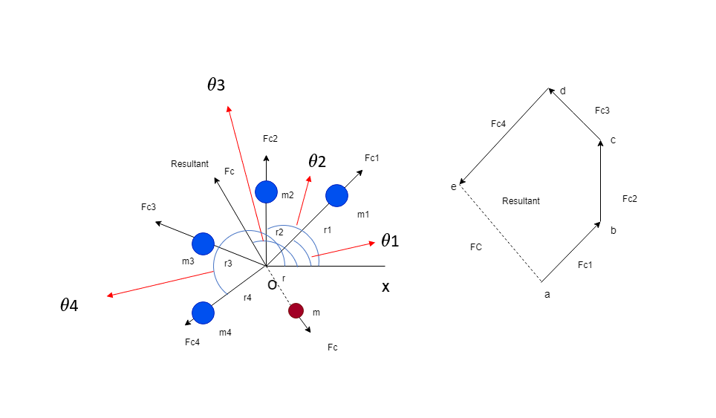

Consider any number of masses (say four) of magnitude m1, m2, m3 and m4 at distance of r1, r2, r3 and r4from the axis of the rotating shaft. Let θ1, θ3 and θ4 be the angles of these masses with horizontal line ox, as shown in figure 1. Let these masses rotate about the axis through O and perpendicular to the plane of paper, with a constant angular velocity of ω rad/sec.

The amount of balanced mass is the resultant of square root of sum of square of horizontal and vertical forces, which is acting in plane

So, the magnitude of resultant centrifugal force



The sum of horizontal component of centrifugal force



The sum of vertical component of centrifugal force



Resultant force vector Fc making inclination with horizontal, which is equals to θ



SOURCE: Theory-of-Machines-14th-ed-Khurmi-2005 (2)

**3. Flowchart:**

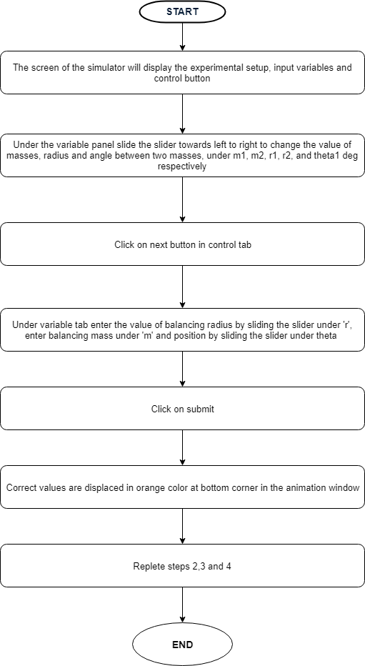

1. **Mindmap:**

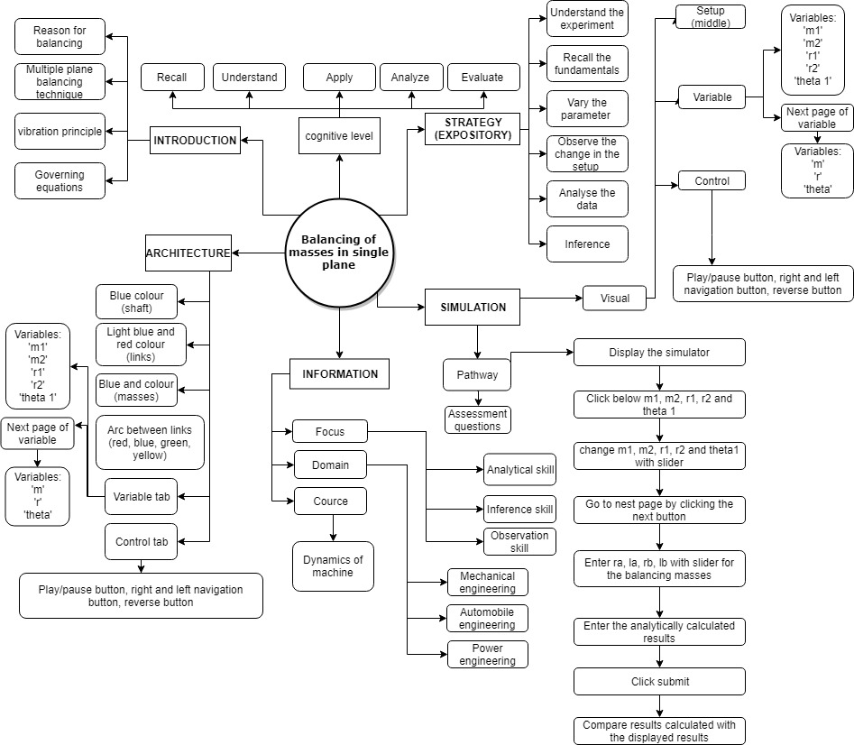

1. **Storyboard:**
   1. In simulation window top of two masses rotating on a shaft is displayed.
   2. There are pointers given on right side of the screen for choosing the values of input variables, viz., two unbalanced masses on the shaft (m1, m2), their radii of rotation (r1, r2) and relative angular position (theta1). After setting these variables, it is required to move on to the next pane by clicking on navigation button at the bottom right corner.

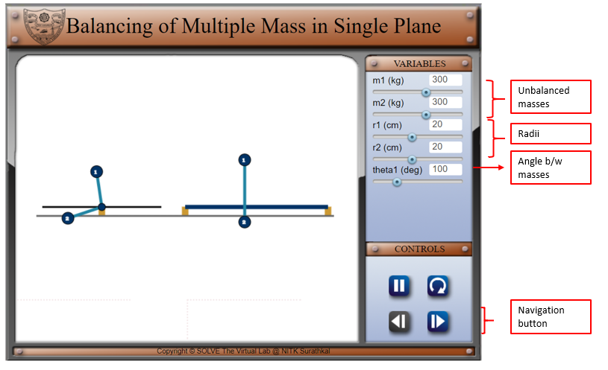

* 1. After moving on to the next pane, the radius and positions of the balancing masses have to be entered by adjusting the slider. After setting the values, it is required by the user to calculate the values of balancing mass.

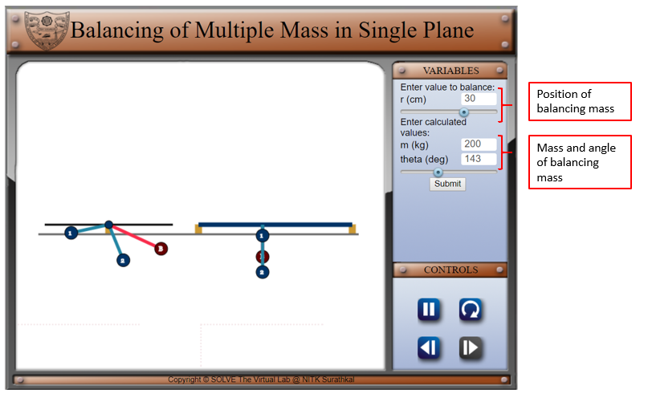

1. Click on submit to submit the results and press paly/pause button to pause the simulation.

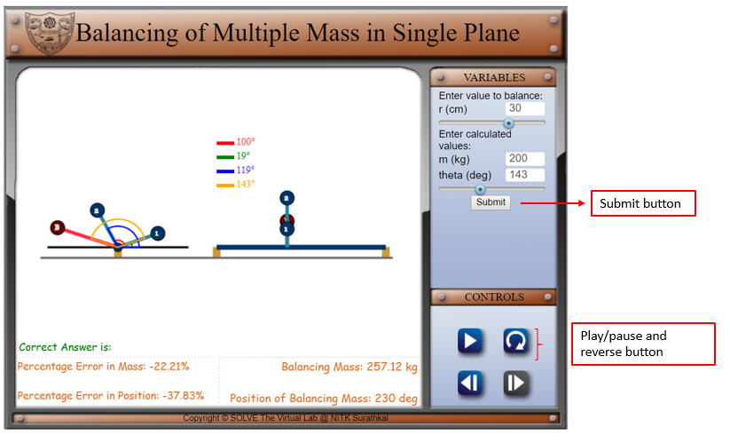

1. Compare analytically calculated results and the error in the result with the simulation results, displayed in the bottom of the simulator page.

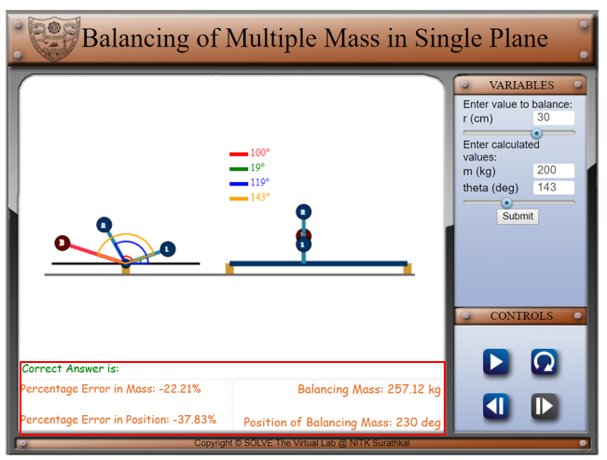

REFERENCE: [1] Theory-of-Machines-14th-ed-Khurmi-2005 (2)